SQL PROJECTS BY ANKIT RAZ MISHRA

Store Background
- A retail store chain tracks daily sales transactions, including order details, customer info, product categories, order times, and order status.
- The business wants to optimize operations, improve customer experience, and increase profitability using data-driven decisions.

Problem Statement
Left side:
"Because of this, they are missing chances to earn more, losing customers, and making poor business decisions."
Right side:
Problem:
- The store doesn’t have a clear idea about
- which products sell the most,
- customers preference,
- which items bring in the most profit, and
- where things are going wrong in delivery or operations.
Solution: "They need proper reports and simple insights to understand their sales, customers, and product performance better."

Why it need to be Solved
Without proper insights:
- 🔹 Missed sales opportunities
- 🔹 Poor inventory and staffing decisions
- 🔹 Increased operational costs
- 🔹 Low customer satisfaction
- 🔹 Inaccurate business forecasts
Solving this will help increase revenue, improve service quality, optimize operations.

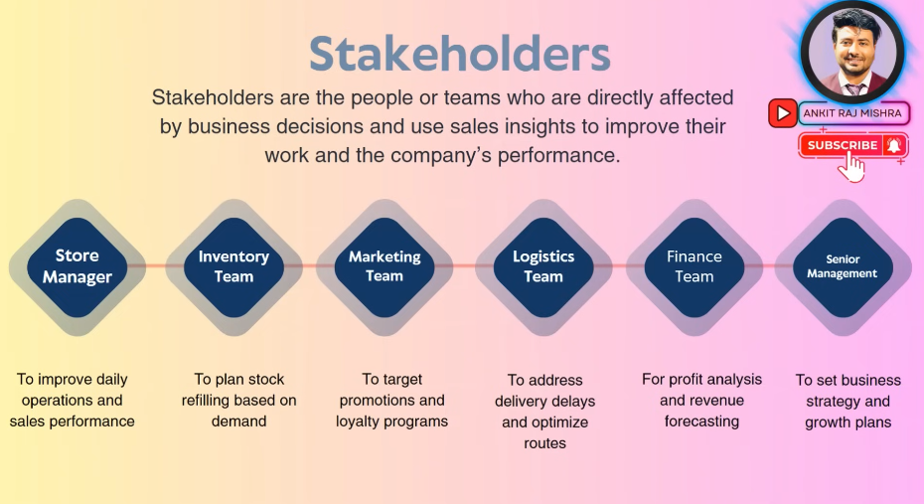

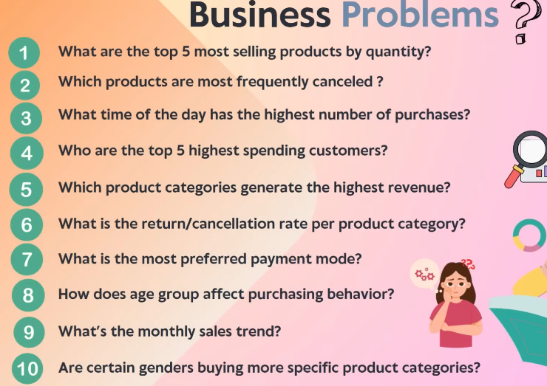

CREATE TABLE sales_store (
transaction_id varchar(15),
customer_id varchar(15),
customer_name varchar(50),
customer_age int,
gender varchar(15),
product_id varchar(15),
product_name varchar(50),
product_category varchar(15),
quantiy int,
prce float,
payment_mode varchar(15),
purchase_date date,
time_of_purchase time,
status varchar(15)
)

select * from sales_store

We using Bulk Insert Method to import the data
set dateformat dmy
bulk insert sales_store
from 'I:\sql projects\Data cleaning\ANKIT RAZ MISHRA\sales_store_updated_allign_with_video.csv'
with (
firstrow = 2,
fieldterminator = ',',
rowterminator = '\n'
);
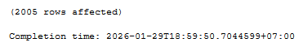
Before we import our data set date format for acceptable by sql otherwise error

Then type
select * from sales_store
to confirm our table

DATA CLEANING
-- Before cleaning data we make temporary table so original data will be safe
select * into sales1 from sales_store

-- Step 1: check and Remove duplicates
select transaction_id, , count(*)
from sales1
group by transaction_id
having count(transaction_id) > 1
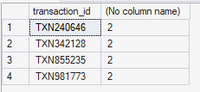

Check in another way
with CTE as (
select *,
ROW_NUMBER() over (partition by transaction_id order by transaction_id) as Row_Number
from sales1
)
select * from CTE
where Row_Number > 1
-- it will show duplicate records with all information

with CTE as (
select *,
ROW_NUMBER() over (partition by transaction_id order by transaction_id) as Row_Number
from sales1
)
select * from CTE
where transaction_id in ('TXN240646', 'TXN342128', 'TXN855235', 'TXN981773')
it will show either number of result either truly duplicates or not

to delete it
with CTE as (
select *,
ROW_NUMBER() over (partition by transaction_id order by transaction_id) as Row_Number
from sales1
)
delete from CTE
where Row_Number = 2
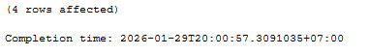

-- Step 2: Correction oh headers
EXEC sp_rename'sales1.quantiy', 'quantity', 'COLUMN'
EXEC sp_rename'sales1.prce', 'price', 'COLUMN'
it will alter the designated name on column as we wish to correct

-- step 3: to check data types of each column

select COLUMN_NAME, DATA_TYPE
from INFORMATION_SCHEMA.COLUMNS
where TABLE_NAME = 'sales1'
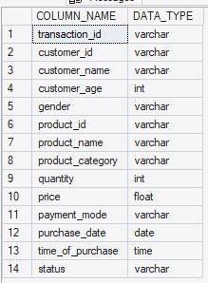

-- step 4: to check for null values in each column

(We can gather below codes from online)

-- check the null count first part

DECLARE @SQL NVARCHAR(MAX) = '';

SELECT @SQL = STRING_AGG(
'SELECT ''' + COLUMN_NAME + ''' AS ColumnName,
COUNT(*) AS NullCount
FROM ' + QUOTENAME(TABLE_SCHEMA) + '.sales1
WHERE ' + QUOTENAME(COLUMN_NAME) + ' IS NULL',
' UNION ALL '
)
WITHIN GROUP (ORDER BY COLUMN_NAME)
FROM INFORMATION_SCHEMA.COLUMNS
WHERE TABLE_NAME = 'sales1';

-- Execute the dynamic SQL
EXEC sp_executesql @SQL;
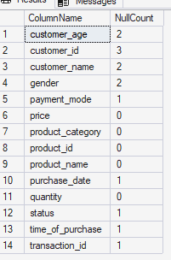

-- treating the null values, check null on every column

select *
from sales1
where transaction_id is null
or
customer_id is null
or
customer_name is null
or
customer_age is null
or
gender is null
or
product_id is null
or
product_name is null
or
product_category is null
or
quantity is null
or
payment_mode is null
or
purchase_date is null
or
status is null
or
price is null
(so we can see how we deal with these null)

Then we write
-- Delete the outliers that exist

delete from sales1
where transaction_id is null
(because transaction_id full of null)
And then we check every name that their customer_id is null
Example:
select * from sales1
where customer_name = 'Ehsaan Ram’ -- we foumd that hos customer_id same so we update

update sales1
set customer_id = 'CUST9494'
where transaction_id = 'TXN977900' --(same row with transaction id that customer_id is null)
select * from sales1
where customer_name = 'Damini Raju'

update sales1
set customer_id = 'CUST1401'
where transaction_id = 'TXN985663'

select * from sales1
where customer_id = 'CUST1003'
update sales1
set customer_name = 'Mahika Saini', customer_age = 35, gender = 'Male'
where transaction_id = 'TXN432798'

-- Step 5: Data Cleaning
-- Step 5: Data Cleaning for ex: in gender column F and Female, suppose only i syllable is required

(Gender Column)
select distinct gender
from sales1

update sales1
set gender = 'M'
where gender = 'Male'

update sales1
set gender = 'F'
where gender = 'Female'
(payment_mode column)
select distinct payment_mode
from sales1

update sales1
set payment_mode = 'Credit Card'
where payment_mode = 'CC'

-- 1. What are the top 5mos selling products by quantity?

select * from sales1
select distinct status
from sales1
(we search for top 5 selling, it mean in the status we eliminate status pending returned, and cancelled items before we proceed)
select top 5 product_name, product_category, sum(quantity) [total_Quantity_sold]
from sales1
where status = 'delivered'
group by product_name, product_category
order by [total_Quantity_sold] desc

-- Business problem: we don't know which products are most in demand
-- Business impact: helps prioritize stock and boost through targeted promotions

-- 2. Which products are most frequently cancelled?
select top 5 product_name, count(*) as total_cancelled
from sales1
where status = 'cancelled'
group by product_name
order by total_cancelled desc

-- Business problem: Frequent cancellation affect revenue and customer trust.
-- Business impact: Identify poor-performing products to improve quality or remove from catalog
-- 3. What time of the day has the highest number of purchases?

select * from sales1

select
case
when datepart(hour, time_of_purchase) between 0 and 5 then 'Night'
when datepart(hour, time_of_purchase) between 6 and 11 then 'Morning'
when datepart(hour, time_of_purchase) between 12 and 17 then 'Afternoon'
when datepart(hour, time_of_purchase) between 18 and 23 then 'evening'
end as time_of_day,
count(*) as total_orders
from sales1
group by
case
when datepart(hour, time_of_purchase) between 0 and 5 then 'Night'
when datepart(hour, time_of_purchase) between 6 and 11 then 'Morning'
when datepart(hour, time_of_purchase) between 12 and 17 then 'Afternoon'
when datepart(hour, time_of_purchase) between 18 and 23 then 'evening'
end
order by total_orders desc

-- Business prroblem solved: Find peak sales times
-- Business impact: Optimizing staffing, prootions, and server loads

-- 4. Who are the top 5 highest spending customers?

select * from sales1

select top 5 customer_name,
format(sum(price*quantity),'C0','en-IN') as total_spend -- N stands for number format
from sales1 -- 0 for no decimal places
where status = 'delivered' -- C stands for currency format $ by default
group by customer_name -- en-IN is for Indian currency format
order by sum(price*quantity) desc

-- Business problem solved : Identity high-value customers
-- Business impact: Personalized offers, loyalty rewards, and retention

-- 5. Which product categories generate the most revenue?

select * from sales1

select product_category,
format(sum(price*quantity),'C0','en-IN') as Revenue
from sales1
group by product_category
order by sum(price*quantity) desc

-- Business problem solved: Identify top revenue-generating categories
-- Business impact: Refine product strategy, supply chain, and promotions
-- Allowing the business to invest more in high-margin or high-emand categories

-- 6. What is the return/cancellation rate by product category?

select * from sales1

-- cancellation

select product_category,
format(count(case when status = 'cancelled' then 1 end)*100.0/count(*),'N3') + ' %'
as cancelled_percentage
from sales1
group by product_category
order by cancelled_percentage desc

-- returned

select product_category,
format(count(case when status = 'returned' then 1 end)*100.0/count(*),'N3') + ' %'
as returned_percentage
from sales1
group by product_category
order by returned_percentage desc

-- Business problem solved: Monitor dissatisfaction trends per category
-- Business impact: Reduces return, improve product description / expectations,
-- Helps identify and fix product or logistic issues

-- 7. What is the most preferred payment method?

select * from sales1

select payment_mode, count(payment_mode) as total_count
from sales1
group by payment_mode
order by total_count desc

-- Business problem solved: Know which payment options customers prefer
-- Business impact: streamline payment processing, prioritize popular methods.

-- 8. How does age group affect purchasing behavior?

select * from sales1
--select min(customer_age), max(customer_age) from sales1

select
case
when customer_age between 18 and 25 then '18-25'
when customer_age between 26 and 35 then '26-35'
when customer_age between 36 and 50 then '36-50'
else '51+'
end as customer_age,
format(sum(price*quantity),'C0', 'en-IN') as total_purchase
from sales1
group by case
when customer_age between 18 and 25 then '18-25'
when customer_age between 26 and 35 then '26-35'
when customer_age between 36 and 50 then '36-50'
else '51+'
end
order by sum(price*quantity) desc

-- Business problem solved: Understand customers demographics
-- Business impact: Targeted marketing, product recommendations by age group.

-- 9. What's the monthly sales trend?

select * from sales1

--Method 1

select
format(purchase_date,'yyyy-MM') as Month_Year,
format(sum(price*quantity),'C0','en-IN') as total_sales,
sum(quantity) as total_quantity
from sales1
group by format(purchase_date,'yyyy-MM')

-- Method 2

select * from sales1

select
--YEAR(purchase_date) as Years,
MONTH(purchase_date) as Months,
format(sum(price*quantity),'C0','en-IN') as total_sales,
sum(quantity) as total_quantity
from sales1
group by MONTH(purchase_date)
order by Months

-- Business problem solved: Sales fluctuations go unnoticed
-- Business impact: plan inventory, marketing according to seasonal trends

-- 10. Are certain genders buying more specific product categories?

select * from sales1

--Method 1
select gender, product_category, count(product_category) as total_purchases
from sales1
group by gender, product_category
order by gender

--Method 2
select *
from (
select gender, product_category
from sales1
) as sourse_table
pivot (
count(gender)
for gender in ([Male], [Female])
) as pivot_table
order by product_category

--or we can use

SELECT
product_category,
COUNT(CASE WHEN gender = 'Male' THEN 1 END) AS Male,
COUNT(CASE WHEN gender = 'Female' THEN 1 END) AS Female
FROM sales1
GROUP BY product_category
ORDER BY product_category;

-- Business problem solved: Gender-based productd preferences
-- Business impact: personalizd ads, gender-focused campaigns

-- Step 7: Uploading project into GitHub

